Day- 1 | SQL

The SQL SELECT Statement

The SELECT statement is used to select data from a database.

ExampleGet: SELECT CustomerName, City FROM Customers;

If you want to return all columns, without specifying every column name, you can use the SELECT \* syntax:

Return all the columns from the Customers table:

SELECT \* FROM Customers;

Exercise1

What is the purpose of the SQL SELECT statement?

Qs:

To insert data into a database

To select data from a database

To delete data from a database

To update data in a database

Ans : To select data from a database

Exerci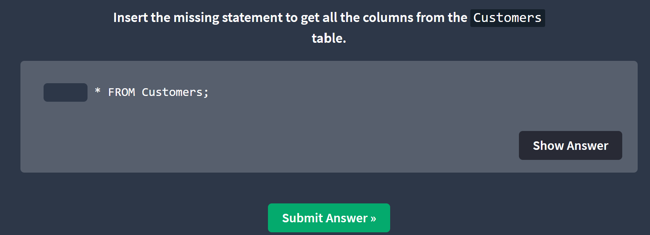Ans : Select

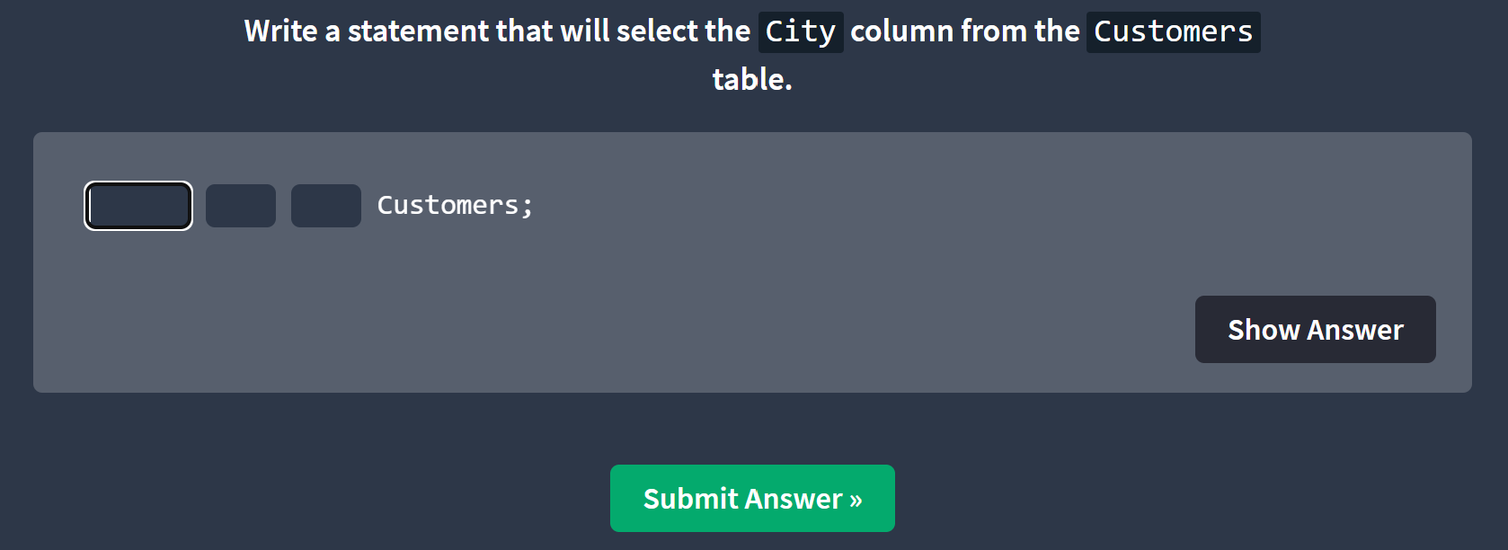



Ans : Select city from customers:

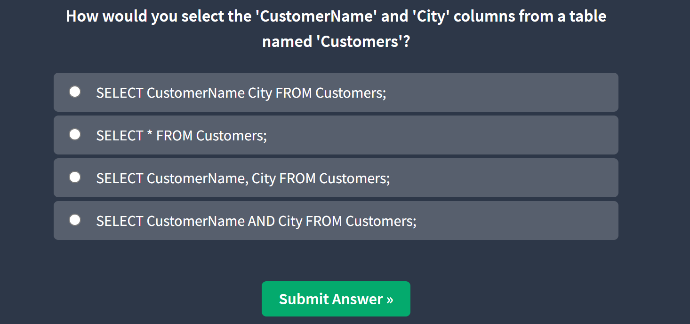

Select CustomerName, City from Customers;

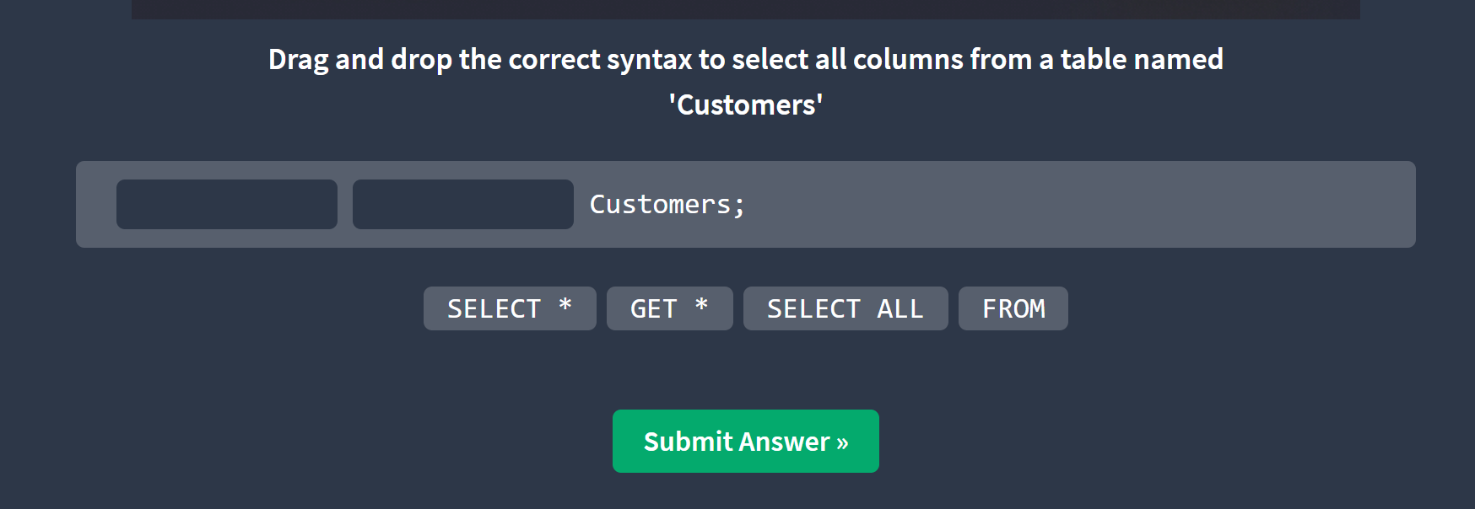

Select \* from Customers:

